About Us | Vishwakarma University Pune, India

Vishwakarma University, Pune - 411048

**Design Document**

ON

**Home Automation using Raspberry pi**

SUBMITTED BY

|  |  |  |
| --- | --- | --- |
| Student Name | SRN | PRN |
| Abhishek Bhosale | 201800183 | 1880030001 |
| Atharv Burade | 201700052 | 1780030004 |
| Ashitosh Kadam | 201800185 | 1880030003 |
| Vaibhav More | 201800907 | 1880030013 |

Class

B. Tech (Computer)

Year

2020-2021

GUIDED BY

Prof. (Dr.) Yogesh Deshpande

DEPARTMENT OF COMPUTER ENGINEERING

About Us | Vishwakarma University Pune, India

Vishwakarma University, Pune - 411048

CERTIFICATE

This is to certify that the following students, studying in B. Tech (Computer Engineering) have satisfactorily completed the work for their Project Stage 1 (Semester I) under my guidance, in the following topic:

Home Automation using Raspberry pi

The report is submitted as a partial fulfillment of the requirement of the Under Graduate degree course in Computer Engineering, Vishwakarma University, during the academic year 2020-2021.

1.Abhishek Suresh Bhosale

2.Atharv Sanjay Burade

3.Ashitosh Shankar Kadam

4.Vaibhav Milind More

Prof. (Dr.) Yogesh Deshpande

Project Guide

(Dept. Computer Engineering)

Acknowledgement

With profound sense of regards, gratitude and indebtedness, we thank Mr. Yogesh Deshpande (Project Guide) for their valuable guidance, incessant and constructive suggestions during course of study.

The project would not have been possible without their zeal and interest throughout the task right from the beginning. We thank them for sharing their invaluable and immense knowledge and timely help which made this project a reality.

|  |  |  |  |  |  |  |
| --- | --- | --- | --- | --- | --- | --- |
| Chapter | | |  | | Table of Contents page no | |
| 1 |  |  |  |  | | **Introduction 6** |
|  | 1.1 |  |  |  | | Purpose 7 |
|  | 1.2 |  |  |  | | Scope 7 |
|  | 1.3 |  |  |  | | Objective 8 |
| 2 |  |  |  |  | | **Literature Survey 10** |
| 3 |  |  |  |  | | **System Design 11** |
|  | 3.1 |  |  |  | | System Architecture 12 |
|  | 3.2 |  |  |  | | User Requirements 12 |
|  | 3.3 |  |  |  | | Requirement 14 |
|  |  | 3.3.1 |  |  | | Hardware Requirements 14 |
|  |  |  | 3.3.1.1 |  | | Raspberry Pi 3B 14 |
|  |  |  | 3.3.1.2 |  | | Raspberry Pi Camera 18 |
|  |  |  | 3.3.1.3 |  | | Power Supply(transformer) 19 |
|  |  |  | 3.3.1.4 |  | | Relay Driver 20 |
|  |  |  | 3.3.1.5 |  | | Temperature Sensor(lm35) 20 |
|  |  |  | 3.3.1.6 |  | | PIR Motion Sensor 21 |
|  |  |  | 3.3.1.7 |  | | 0 Bulb 22 |
|  |  | 3.3.2 |  |  | | Software Requirement 23 |
|  |  |  | 3.3.2.1 |  | | Raspbian Operating System 23 |
|  |  |  | 3.3.2.2 |  | | Win32 Disk Imager 24 |
|  |  |  | 3.3.2.3 |  | | Thing Speak 25 |
|  |  |  |  | A | | Creating Channels 26 |
|  |  |  |  | B | | API Keys 27 |
|  |  |  |  | C | | API Request 28 |
|  |  |  |  | D | | Private View 29 |
|  |  |  | 3.3.2.4 |  | | MIT App Inventor 30 |
| 4 |  |  |  |  | | **Detail Design 32** |
|  | 4.1 |  |  |  | | DFD’s 33 |
|  | 4.2 |  |  |  | | DFD Level 1 33 |
|  | 4.3 |  |  |  | | DFD Level 2 34 |
|  | 4.4 |  |  |  | | Use Case Diagram 35 |
|  | 4.5 |  |  |  | | Sequence diagram 36 |
|  | 4.6 |  |  |  | | Block diagram 37 |
| 5 |  |  |  |  | | **Testing** |
|  | 5.1 |  |  |  | | System Testing 39 |
|  | 5.2 |  |  |  | | Block Testing 39 |
|  | 5.3 |  |  |  | | Unit Testing 40 |
| 6 |  |  |  |  | | **Project Planning 42** |
| 7 |  |  |  |  | | **References 44** |
| 8 |  |  |  |  | | **Conclusion 46** |

*CHAPTER 1: INTRODUCTION*

**1.1 Purpose**

Home automation is the use of one or more computers to control basic home functions and features automatically and sometimes remotely. An automated home is sometimes called a [smart home](http://searchcio-midmarket.techtarget.com/definition/smart-home-or-building) .

Home automation can include the scheduling and automatic operation of water sprinkling, heating and air conditioning, window coverings, security systems, lighting, and food preparation appliances. Home automation may also allow vital home functions to be controlled remotely from anywhere in the world using a computer connected to the Internet. Besides the functions already mentioned, remote control can be extended to telephones and answering machines, fax machines, amateur radios and other communications equipment, and [home robot](http://searchcio-midmarket.techtarget.com/definition/smart-home-or-building) s such as automatic vacuum cleaners. Home automation system is one of the automation systems, which is used for [controlling home appliances automatically](https://www.elprocus.com/home-automation-projects-engineering-students/)(sometimes remotely) with the help of various control systems.

The home automation systems are used for controlling the indoor & outdoor lights, heat, ventilation, air conditioning in the house, to lock or open the doors & gates, to control electrical & electronic appliances and so on using various control systems with appropriate sensors.

The Internet of Things, commonly referred to as IoT, is the network of physical objects, devices, vehicles, buildings, and other items that’s been integrated into the technology of modern electronics, software, sensors, and other “things” with network connectivity that enables them to collect and exchange data. Once collected, this data becomes a powerful resource, which companies and technologies are tapping into, in revolutionary ways.

**1.Increases home security**

**2.Savings on bills**

**3.Control all functions remotely**

**1.2 Scope of Project**

Future scope for the home automation systems involves making homes even smarter. Homes can be interfaced with sensors including motion sensors, light sensors and temperature sensors and provide automated toggling of devices based on conditions. More energy can be conserved by ensuring occupation of the house before turning on devices and checking brightness and turning off lights if not necessary.

The system can be integrated closely with home security solutions to allow greater control and safety for home owners. The next step would be to extend this system to automate a large-scale environment, such as offices and factories. Home Automation offers a global standard for interoperable products. Standardization enables smart homes that can control appliances, lighting, environment, energy management and security as well as the expandability to connect with other networks.

**1.3 Objective**

the main objective of this project is to develop a home automation using raspberry pi with internet being remotely controlled by any Android OS smart phone. As Technology is advancing so houses are also getting smarter. Modern houses are gradually shifting from conventional switches to centralized control system, involving remote controlled switches. Presently, conventional wall switches located in different parts of the house makes it difficult for the user to go near them to operate. Even more it becomes more difficult for the elderly or physically handicapped people to do so. Remote controlled home automation system provides a most modern solution with smart phones.

*CHAPTER 2: LITERATURE SURVEY*

Review of Related Literature:

When people think about home automation, most of them may imagine living in a smart home: One remote controller for every household appliance, cooking the rice automatically, starting air conditioner automatically, heating water for bath automatically and shading the window automatically when night coming. To some extent home automation equals to smart home. They both bring out smart living condition and make our life more convenient and fast.

Review of Foreign Studies:

In their paper, Tan, Lee and Soh (2002) proposed the development of an Internet-based system to allow monitoring of important process variables from a distributed control system (DCS). This paper proposes hardware and software design considerations which enable the user to access the process variables on

the DCS, remotely and effectively Potamitis, Georgila, Fakotakis, and Kokkinakis, G. (2003) suggested the use of speech to interact remotely with the home appliances to perform a particular action on behalf of the user. The approach is inclined for people with disability to perform real-life operations at home by directing appliances through speech. Voice separation strategy is selected to take appropriate decision by speech recognition

In the year 2006 , S. M. Anamul Haque,S. M. Kamruzzaman and Md. Ashraful Islam proposed a system entitled “A System for Smart-Home Control of Appliances Based on Time and Speech Interaction” that controls the home appliances using the personal computer. This system is developed by using the Visual Basic 6.0 as programming language and Microsoft voice engine tools for speech recognition purpose. Appliances can be either controlled by timer or by voice command.

Ciubotaru-Petrescu, Chiciudean, Cioarga, and Stanescu (2006) present a design and implementation of SMS based control for monitoring systems. The paper has three modules involving sensing unit for monitoring the complex applications. A processing unit, that is microcontroller and a communication module that uses GPRS modem or cell phone via serial port RS-232. The SMS is used for status reporting such as power failure. Jawarkar, Ahmed, Ladhake, and Thakare (2008) propose remote monitoring through mobile phone involving the use of spoken commands. The spoken commands are generated and sent in the form of text SMS to the control system and then the microcontroller on the basis of SMS takes a decision of a particular task. Prof. Era Johri Dept. Of Information And Technology K.J.Somaiya College Of Engineering VIDYAVIHAR, MUMBAI “Remote Controlled Home Automation Using Android Application via WiFi Connectivity”.

*CHAPTER 3: SYSTEM DESIGN*

**3.1 System Architecture**

System design is a process of defining the architecture, components, modules, interfaces, and data for a system to satisfy the specified requirements.

"Software architecture is the structure of the components of a program/system, their interrelationships, and principles and guidelines governing their design and evolution over time".

Firstly, the raspberry pi is been coded by python programming language. Then we are connecting the home

appliances to the raspberry pi pins which are called as GPIO (General purpose input output) pins. We will connect fan and bulb to the GPIO pins

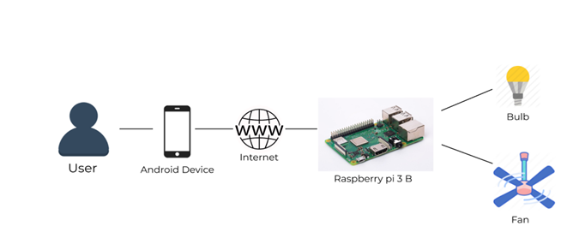

**Fig 3.1 System Architecture**

in Fig 2.1 figure we see how various modules are been connected and how they communicate with each other and how appliances are been connected and controlled.

**3.2 User Requirements**

**Lighting control systems:** Imagine the effect of pressing a button and dramatically changing the lighting ambience and the visual environment in a living space! An easy to use system, a reliable technology and setting the right presets could benefit the end-user.

**Motorized shading systems:** Increasingly, the idea of manually moving huge curtains and blinds is giving way to the convenience of using a simple press of a button to change the natural light coming into the house, by using motorized shades.

**Automation of A/V devices:** The ability to control all AV devices from a single touch panel, User-friendly macros, where in a sequence of operations happens every time a button in enabled, assists the user. For e.g.  pressing the movie “scene” in a living room could dim lights, turn on the TV, turn on the Amplifier, turn on the Blue Ray player and also draw the curtains etc. all with just one press of the movie button, on your smart phone.

**Media distribution, storage and display:** With the ever-increasing demands on resolution (4k TV, 8k TV etc.), it is important that we lay the wiring/hardware capable of transmitting the highest resolution in picture and audio possible, at least as of today. Media could be and should be available to be played anywhere in the house, from the cloud or from a local Media server.

**HVAC controls:** Smart home owners today have the ability to control and monitor the HVAC system in the house. Not only is control possible, monitoring with two-way feedback allows energy saving when certain areas do not need conditioning.

**Security Systems:** While security systems have existed for a long long time, the smart home has a security system that is integrated with the rest of the house controls. For e.g. when the security system detects an intrusion, it starts flashing the lighting in the entire house on/off. It sends a notification to the home owner phone and scares away a potential intruder.

**3.3 REQUIREMENTS**

* + 1. **HARDWARE REQUIREMENTS**

**3.3.1.1 RASPBERRY PI 3B**

The raspberry pi is the most vital part of the mirror, it forms the processing unit of the mirror. The Pi is like motherboard having all the required constituents which forms a great CPU. This CPU taken the information from sensors, camera & from the URL which we are providing in the program and runs that information through the model and identifies the user and display that information on the mirror with the help of GLCD. Its size of a credit card and still it can perform like a full-fledged computer. The programming of Pi is done using Python language. The GPIO pins on Raspberry Pi controls the 8-Channel relay through which we can control the electronic devices connected to it. The Raspberry Pi has inbuilt Wi-Fi and Bluetooth for connectivity purpose as well as it allows 4 USB devices to be plugged in.

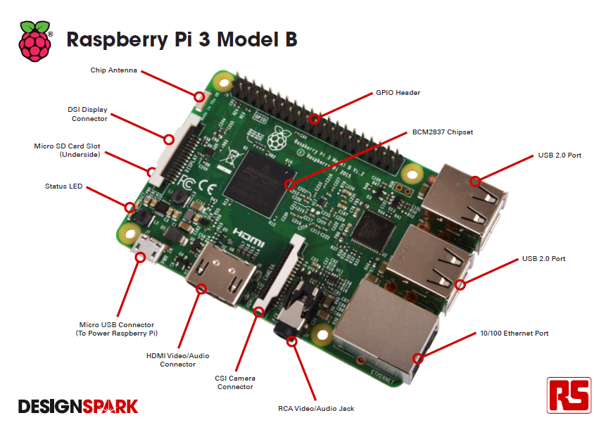

**Fig 3.3.1.1 Raspberry Pi 3B**

The Raspberry Pi 3 Model B is the third generation Raspberry Pi. This powerful credit-card sized single board computer can be used for many applications and supersedes the original Raspberry Pi Model B+ and Raspberry Pi 2 Model B. Whilst maintaining the popular board format the Raspberry Pi 3 Model B brings you a more powerful processer, 10x faster than the first-generation Raspberry Pi. Additionally, it adds wireless LAN & Bluetooth connectivity making it the ideal solution for powerful connected designs.

**Specifications**

Processor Broadcom BCM2387 chipset.

1.2GHz Quad-Core ARM Cortex-A53

802.11 b/g/n Wireless LAN and Bluetooth 4.1 (Bluetooth Classic and LE)

GPU Dual Core VideoCore IV® Multimedia Co-Processor. Provides Open GL

ES 2.0, hardware-accelerated OpenVG, and 1080p30 H.264 high-profile decode.

Capable of 1Gpixel/s, 1.5Gtexel/s or 24GFLOPs with texture filtering and DMA infrastructure

Memory 1GB LPDDR2

Operating System Boots from Micro SD card, running a version of the Linux operating system or Windows 10 IoT

Dimensions 85 x 56 x 17mm

Power Micro USB socket 5V1, 2.5A

**Connectors**:

Ethernet 10/100 BaseT Ethernet socket

Video Output HDMI (rev 1.3 & 1.4 Composite RCA (PAL and NTSC)

Audio Output Audio Output 3.5mm jack, HDMI

USB 4 x USB 2.0 Connector

GPIO Connector 40-pin 2.54 mm (100 mil) expansion header: 2x20 strip

Providing 27 GPIO pins as well as +3.3 V, +5 V and GND supply lines

Camera Connector 15-pin MIPI Camera Serial Interface (CSI-2)

Display Connector Display Serial Interface (DSI) 15 way flat flex cable connector with two data

lanes and a clock lane

Memory Card Slot Push/pull Micro SDIO

**Key Benefits** • Low cost • Consistent board format

• 10x faster processing • Added connectivity

**Key Applications** • Low-cost PC/tablet/laptop • IoT applications

• Media centre • Robotics

• Industrial/Home automation • Server/cloud server

• Print server • Security monitoring

• Web camera • Gaming

• Wireless access point

• Environmental sensing/monitoring (e.g. weather station)

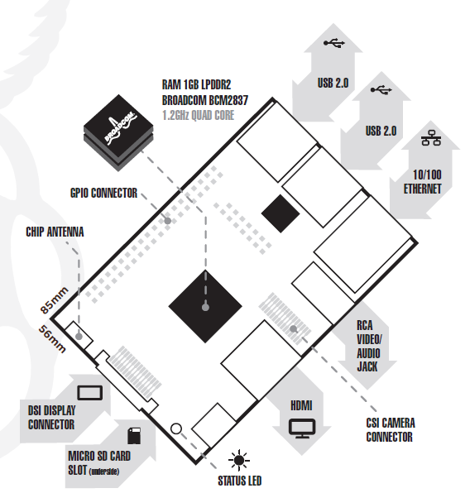

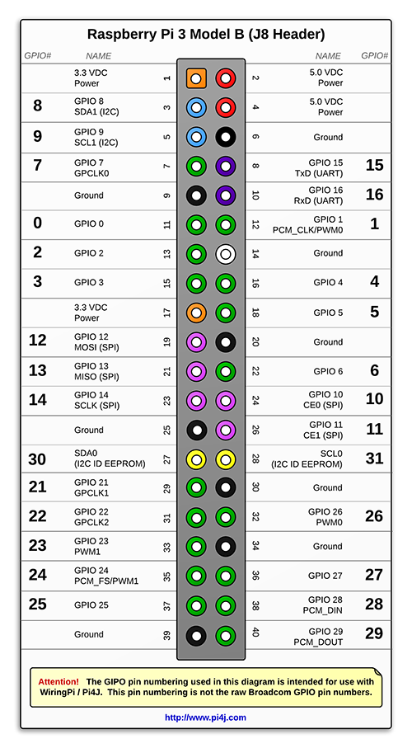

**Pin Description**

**3.3.1.2 RASPBERRY PI CAMERA:**

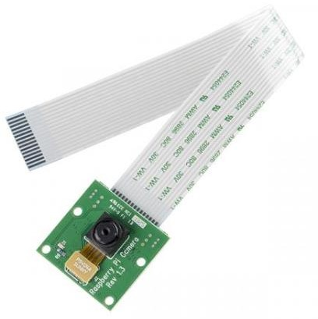

The high-definition 5MP camera delivers outstanding photos but can also shoot video, ideal for drones or a CCTV project. The lightweight camera module allows for it to be used in more practical roles, such as a hidden camera or even a camera for a Pi-phone*.* This [Raspberry](https://robu.in/product-category/raspberry-pi/raspberry-pi-accessories/camera-accessories-for-pi/) [Pi Camera Module](https://robu.in/product-category/raspberry-pi/raspberry-pi-accessories/camera-accessories-for-pi/) is a custom designed add-on for Raspberry Pi. It attaches to [Raspberry](https://robu.in/product-category/raspberry-pi/raspberry-pi-boards/) [Pi](https://robu.in/product-category/raspberry-pi/raspberry-pi-boards/) by way of one of the two small sockets on the board upper surface. This interface uses the dedicated CSI interface, which was designed especially for interfacing to cameras. The CSI bus is capable of extremely high data rates, and it exclusively carries pixel data.

It connects to Raspberry Pi by way of a short [flexible ribbon cable**.**](https://robu.in/product/raspberry-pi-zero-v1-3-camera-cable/)The camera connects to the BCM2835 processor on the Pi via the CSI bus, a higher bandwidth link which carries pixel data from the camera back to the processor. This bus travels along the ribbon cable that attaches the [camera](https://robu.in/product-category/camera/) board to the Pi. The [sensor](https://robu.in/product-category/sensors/) itself has a native resolution of 5 megapixels and has a fixed focus lens onboard. In terms of still images, the camera is capable of 2592 x 1944 pixel static images, and also supports 1080p30, 720p60 and 640x480p60/90 video.

Features:

• Resolution: 5 MP

• Interface Type: CSI(Camera Serial Interface)

• Dimensions: 25x23x8 (LxWxH) mm

• Supported Video Formats: 1080p @ 30fps, 720p @ 60fps and 640x480p 60/90 video

• Fully Compatible with Raspberry Pi 3 Model B.

• Plug-n-Play camera for Raspberry Pi 3 Model B.

**3.3.1.3 Power Supply**

The power supply is most important for electronic circuits, which provide required power to the raspberry pi and other electronic device. For this system we are using 5V power supply for Raspberry pi, LM35, PIR, DC motor.

The basic step in the designing of any system is to design the power supply required for that system.

1. Step down transformer
2. Bridge rectifier
3. Filter capacitor
4. Voltage regulator

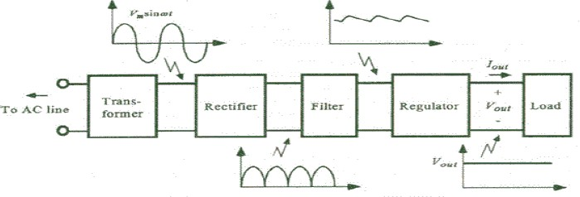

the operation of power supply built using filters, rectifiers and then voltage regulator. The AC voltage typically 230Vrms is applied to primary winding of transformer which steps down that AC voltage to the desired AC voltage. Rectifier provides pulsating DC voltage at its output. This DC voltage has some ripple. A filter is use to filtered out that ripples and we get dc voltage. The regulator is used to provide constant voltage.

**3.3.1.4 RELAY DRIVER**

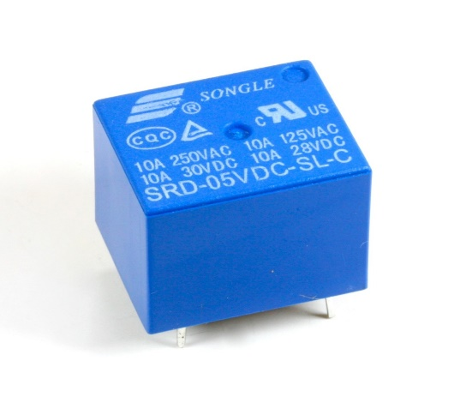

A Relay driver IC is an electro-magnetic switch that will be used whenever we want to use a low voltage circuit to switch a light bulb ON and OFF which is connected to 220V mains supply. The required current to run the relay coil is more than can be supplied by various integrated circuits like Op-Amp, etc. Relays have unique properties and are replaced with solid state switches that are strong than solid-state devices. High current capacities, capability to stand ESD and drive circuit isolation are the unique properties of Relays. There are various ways to drive relays. Some of the Relay Driver ICs are as below.

**3.3.1.5 Temperature Sensor (LM35)**

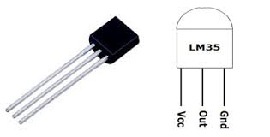

1.LM35 is a temperature measuring device having an analog output voltage proportional to the temperature.

2.It provides output voltage in Centigrade (Celsius). It does not require any external calibration circuitry.

3.The sensitivity of LM35 is 10 mV/degree Celsius. As temperature increases, output voltage also increases.

E.g. 250 mV means 25°C.

4.It is a 3-terminal sensor used to measure surrounding temperature ranging from -55 °C to 150 °C.

5.LM35 gives temperature output which is more precise than thermistor output.

# **3.3.1.6 PIR Motion Sensor (HC-SR501)**

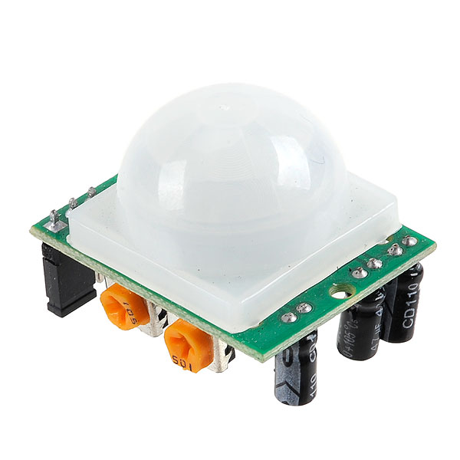

A motion sensor (or motion detector) is the linchpin of your security system, because it’s the main device that detects when someone is in your home when they shouldn’t be. A motion sensor uses one or multiple technologies to detect movement in an area. If a sensor is tripped, a signal is sent to your security system’s control further action. panel, which connects to your monitoring center, alerting you and the monitoring center to a potential threat in your home.

In this system we are using PIR motion sensor. PIR sensors allow you to sense motion, almost always used to detect whether a human has moved in or out of the sensors range. They are often referred to as PIR, "Passive Infrared", "Piezoelectric", or "IR motion" sensors. When there is no one in the room the security mode is active and Motion sensor sense the motion by comparing corresponding features of all above sensors we are selecting to use PIRs sensor are basically made of a piezoelectric sensor (which you can see below as the round metal can with a rectangular crystal in the center), which can detect levels of infrared radiation. The sensor in a motion detector is actually split in two halves. The reason for that is that we are looking to detect motion (change) not average IR levels.

SPECIFICATIONS –

1.PIRs are basically made of a pyroelectric sensor, which can detect levels of infrared radiation.

2.Above figure of PIR element shows the round metal can with a rectangular crystal in the centre.

3.Every object emits some low-level radiation, and the hotter objects emits more radiations.

4.Wide range on input voltage varying from 4.V to 12V (+5V recommended)

5.Output voltage is High/Low (3.3V TTL)

6.Can distinguish between object movement and human movement

7.Has to operating modes - Repeatable(H) and Non- Repeatable(H)

8.Cover distance of about 120° and 7 meters

9.Low power consumption of 65mA

10.Operating temperature from -20° to +80° Celsius

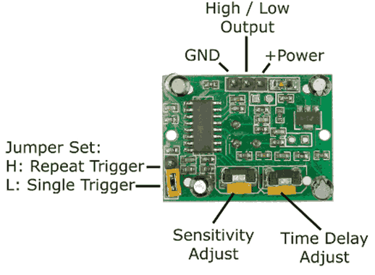

**3.3.1.7 0 BULB**

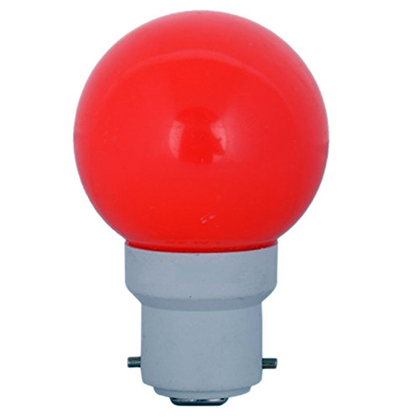

Zero-watt bulbs consume 12-15 watts of power. However, in older days, when all the appliances were turned off and only the zero-watt bulb was kept on, the ‘not so sophisticated’ electromagnetic meter could not measure power of such less magnitude. The meter read ‘zero’ power and hence the name zero-watt bulb. This misconception led to the unchecked usage of these bulbs.

**3.3.2 SOFTWARE REQUIREMENTS**

**3.3.2.1 RASPBIAN OPERATING SYSTEM**

To provide interface to component used in system, software is necessary. Raspberry pi has its own operating system. Software used are descripted below

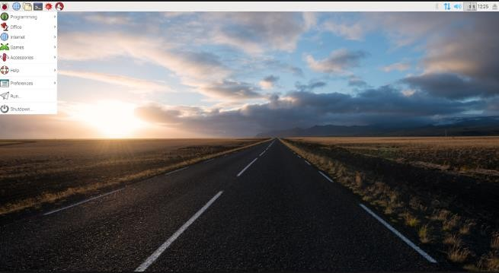

**Figure : Raspbian OS window**

**Raspbian** is the “official” operating system of the Raspberry Pi and because of that, it's the one most popular software with which people will want to start with. **Raspbian** Is the Best All-Around Operating System. **Raspbian** is the “official” operating system of the Raspberry Pi. **Raspbian** is a version of **Linux** built specifically for the Raspberry Pi. It comes packed with all the software you'll need for every basic task with computer. Raspbian which is based on Linux Debian is used as an operating system for the proposed project which has a strong documentation. Raspbian comes pre-installed with plenty of software for education, programming and general use. It has Python, Scratch, Sonic Pi, Java, Mathematica and more. The Raspbian with PIXEL image contained in the ZIP archive is over 4GB in size, which means that these archives use features which are not supported by older unzip tools on some platforms

**3.3.2.2 WIN32 DISK IMAGER**

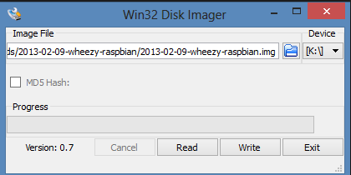

**Figure 7.2: WIN 32 disk imager window**

This is a Windows program for saving and restoring images from removable drives (USB drives, SD Memory cards, etc). It can be used to write boot images to a SD Flash device or USB flash device, making it bootable. Win32DiskImager supports writing an ISO image to SD card.

This program is designed to write a raw disk image to a removable device or backup a removable device to a raw image file. It is very useful for embedded development, namely Arm development projects (Android, Ubuntu on Arm, etc). Anyone is free to branch and modify this program. Patches are always welcome.

Insert your SD Card and then run Win32DiskImager.. It may give an error message on startup, but you can often ignore it. It should find your SD Card drive or if not select it. Select the file '#.img' image file you wish to use and then press write. Once it completes you are ready to go, insert your SD card into the Raspberry Pi

**3.3.2.3 ThingSpeak**

ThingSpeak is an IoT analytics platform service that allows you to aggregate, visualize and analyze live data streams in the cloud. ThingSpeak provides instant visualizations of data posted by your devices to ThingSpeak. With the ability to execute MATLAB® code in ThingSpeak you can perform online analysis and processing of the data as it comes in. ThingSpeak is often used for prototyping and proof of concept IoT systems that require analytics.

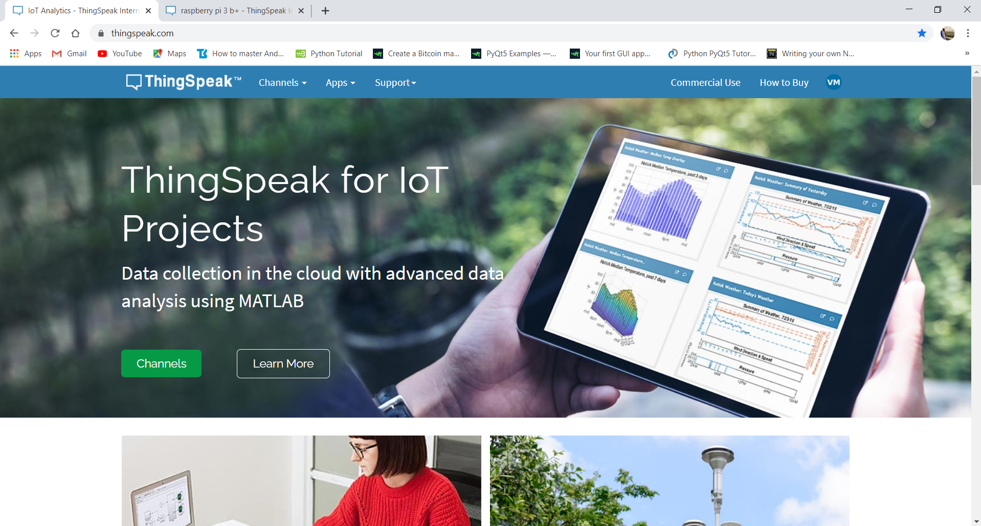

**A. Creating Channels**

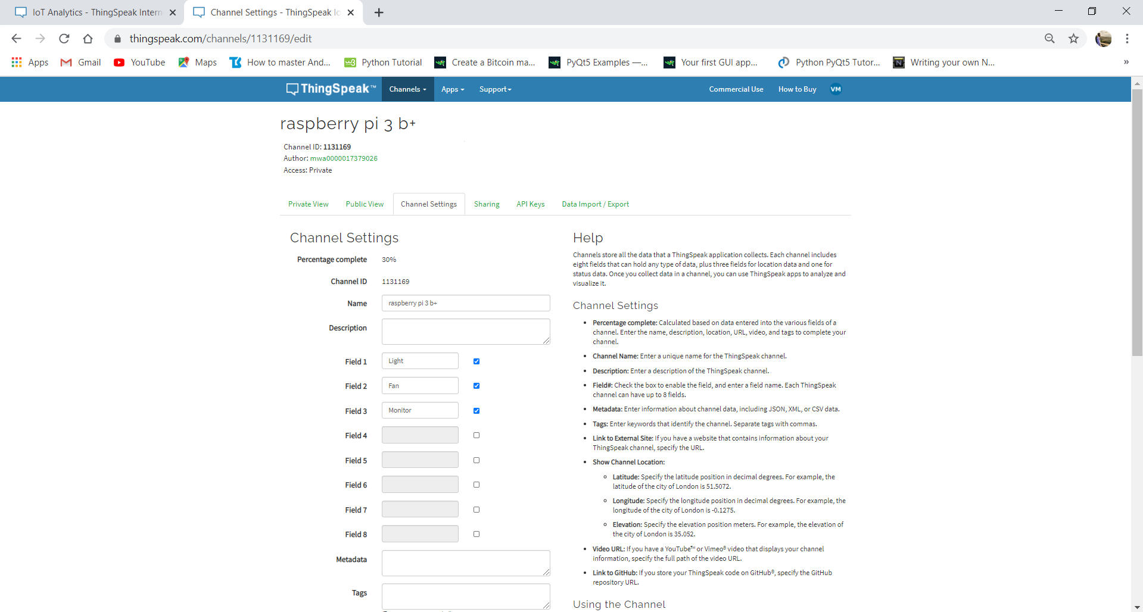

**B. API Keys**

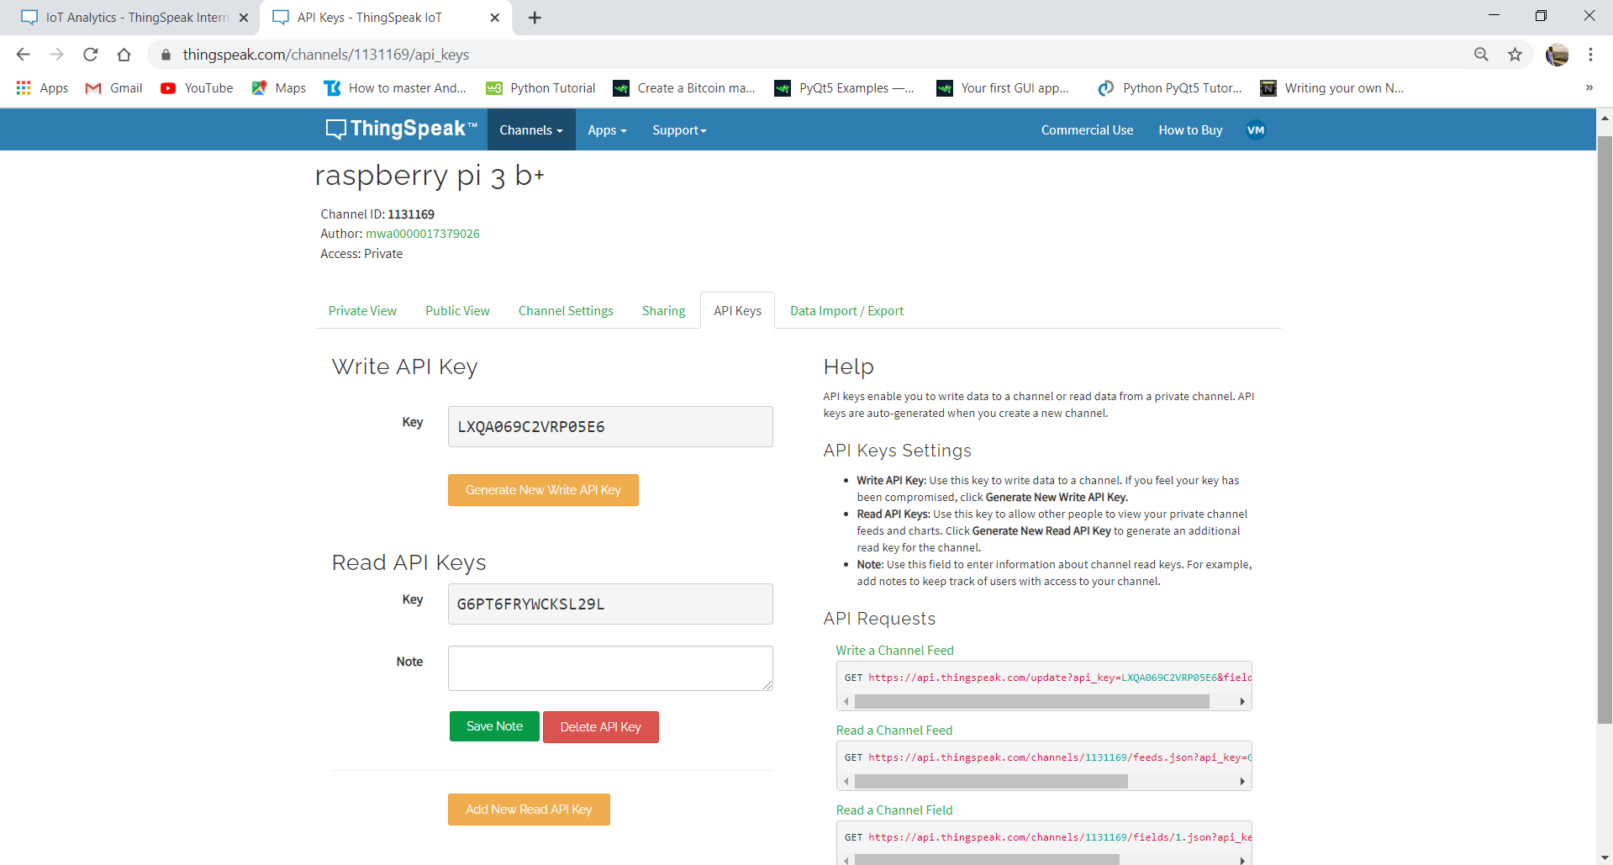

**C. API Request**

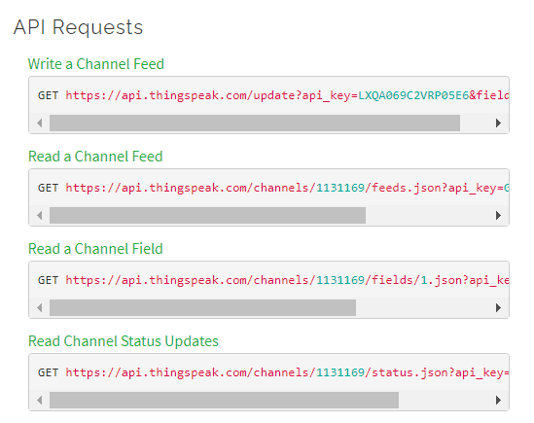

**D. Private View**

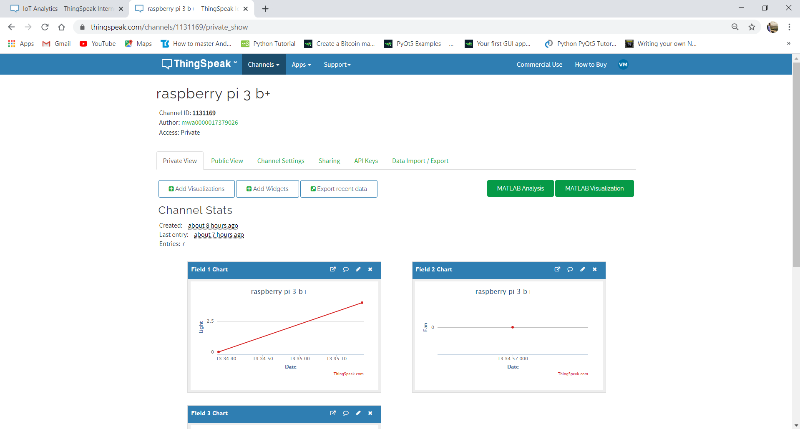

**3.3.2.4 MIT APP INVENTOR**

MIT App Inventor is a web application integrated development environment originally provided by Google, and now maintained by the Massachusetts Institute of Technology.

MIT app inventor is used to create mobile application. App inventor for android is an open source web application originally provided by goggle, and now maintained by the Massachusetts Institute of Technology. It uses a graphical interface, very similar to Scratch and the Start Logo TNG user interface, which allows users to drag and drop visual objects to create an application that can run on Android device. In creating App Inventor, Google drew upon significant prior research in educational computing, as well as work done within Google on online development environments. App inventor also supports the use of cloud data via an experimental firebase DB component.

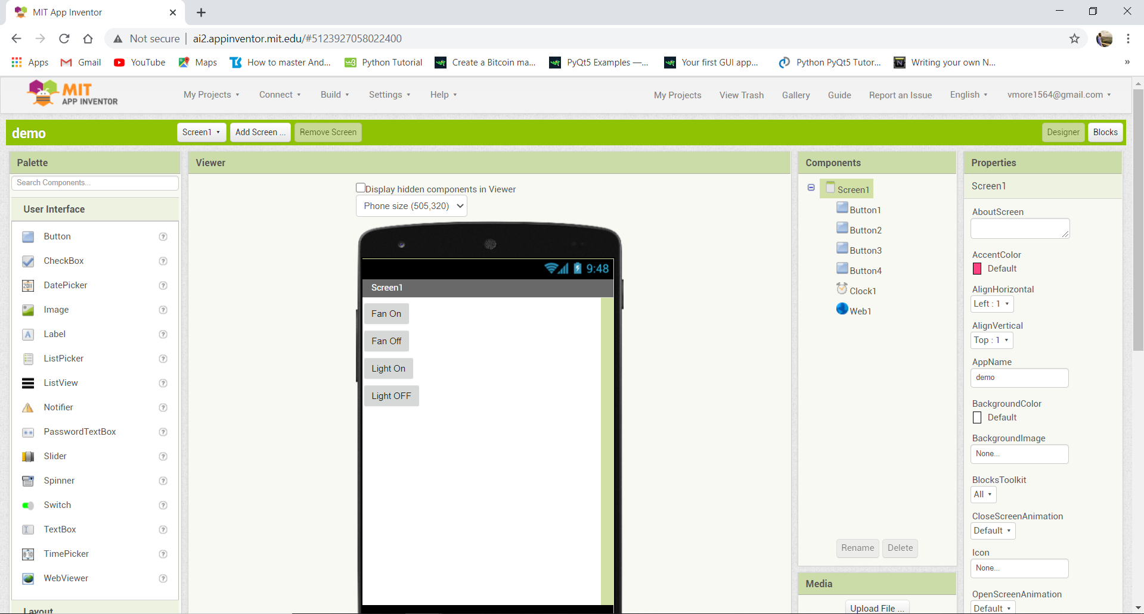

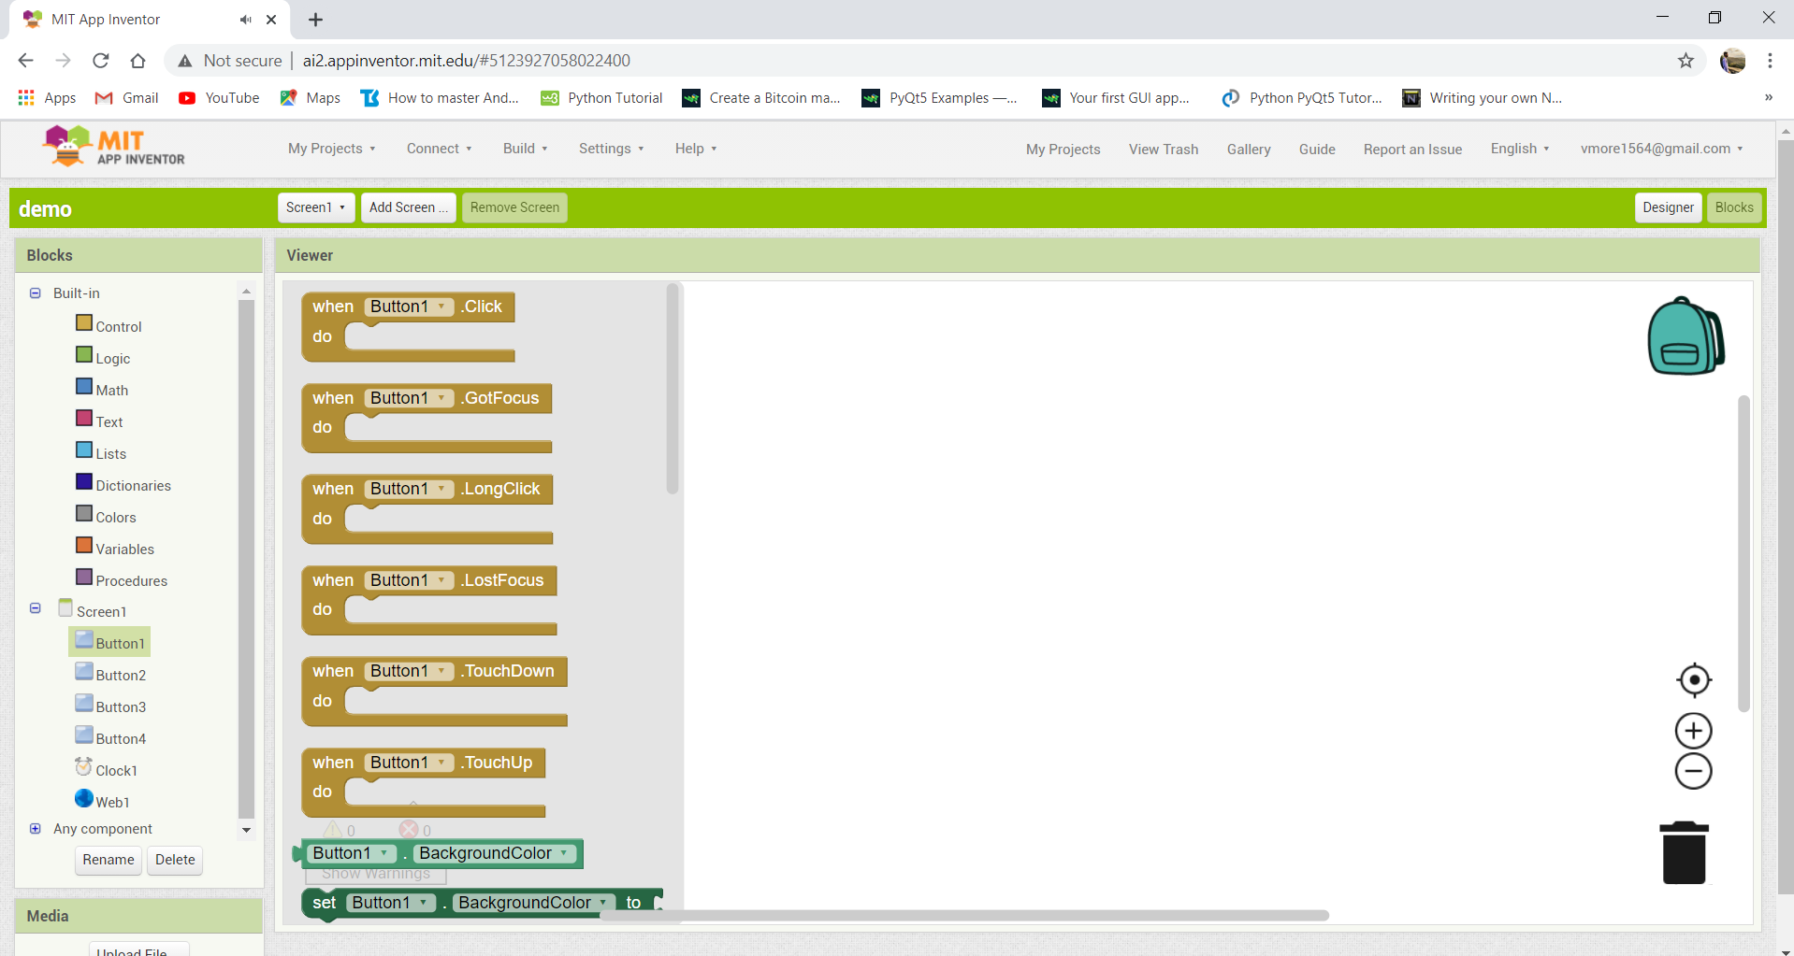

*CHAPTER 4: DETAIL DESIGN*

**4.1 DFD’s**

The Data flow diagrams (DFDs) is the graphical representation of a system that shows the inputs to the system, the processing upon the inputs, outputs of the system as well as the internal data stores. DFD illustrates the series of transformations or computations performed on the objects or the system

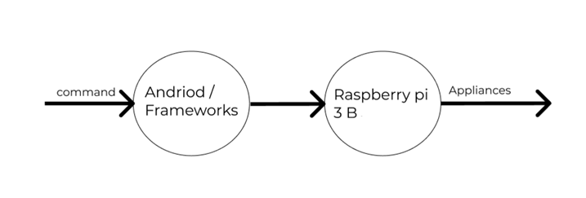

**Fig 4.1 Context Level 0**

**4.2 DFD Level 1**

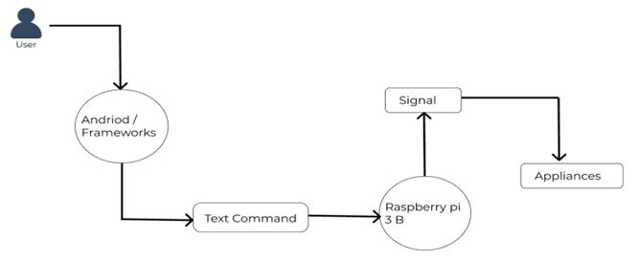

**Fig 4.2 Level 1 DFD**

The above figure will show us the Level1 DFD where the commands from the user given to the android app which are been passed to the raspberry pi then the signals from the raspberry pi are been sent to the appliances which are been controlled.

**4.3 DFD Level 2**

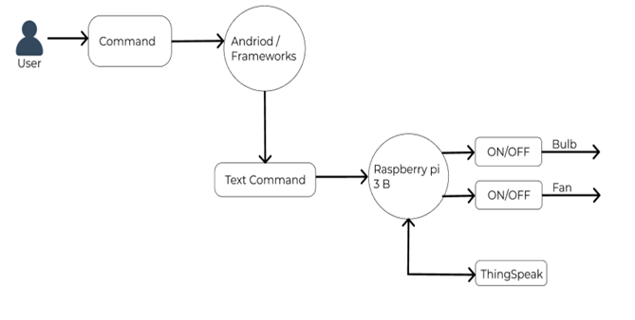

**Fig 4.3 Level 2 DFD**

The above figure will show the Level 2 DFD where the commands been sent to by android app are been passed to the hardware module. The database will be checked after every second to see whether the database is been updated or changed then according to the commands the fan and bulb are been controlled.

**4.4 USE CASE Diagram**

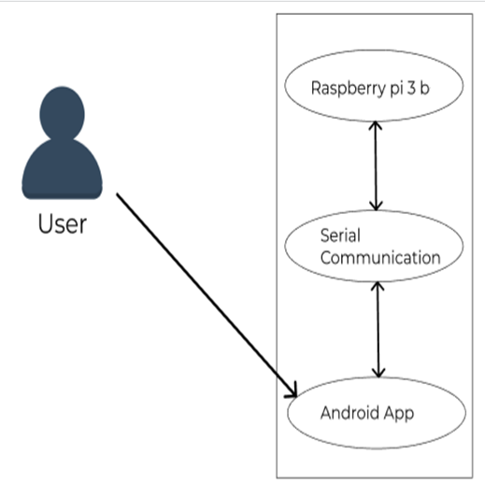

**Fig 4.4 Use Case Diagram**

A use case diagram is a graphic depiction of the interactions among the elements of a system. A use case is a methodology used in system analysis to identify, clarify, and organize system requirements. Use case diagram shows the communication between actor and system. In our system actor is a user who will just open the application and click on the icon and gives the commands and these commands been sent to the raspberry pi later the appliances are been controlled according to the given commands.

**4.5 Sequence Diagram**

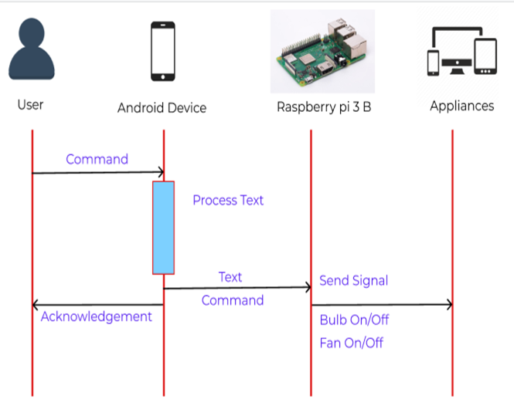

**Fig 4.5 Sequence Diagram**

A sequence diagram is an interaction diagram that shows how processes operate with one another and what is their order. A sequence diagram shows object interactions arranged in time sequence. It depicts the objects and classes involved in the scenario and the sequence of messages exchanged between the objects needed to carry out the functionality of scenario. The below diagram will show us how the commands are been carried out from one module to other module to control appliances. The user will send the commands to android app later the commands sent to raspberry pi to control appliances

**4.6 Block Diagram**

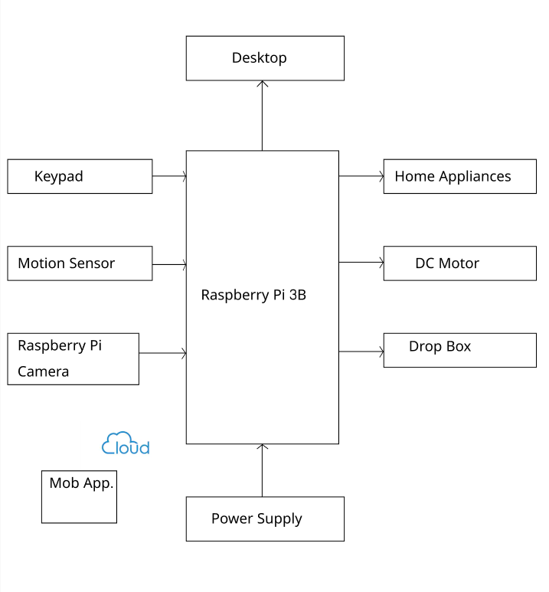

**Fig 4.6 Block Diagram**

Fig 2.7 represents the block diagram of home automation system using Raspberry pi . All the home appliances are connected with Raspberry Pi, Mobile phone and Raspberry Pi are connected through Internet. Raspberry Pi is used as the board controller to connect the appliances via input and output port. We can use cloud server for controlling and monitoring the home appliances from anywhere.

*CHAPTER 5: TESTING*

**5.1 SYSTEM TESTING**

The framework going for delicate products is the looking at achieved on an outright, included machine to assess the machine's congruity with its exact necessities. gadget testing would also fall inside the range of the dark compartment looking at, and in this way, it must need no data around the interior structuring of the presence of mind or the code. It's miles a totally comparable deliberate check case lettering. inside the check case lettering we ought to be equipped for compose the check case circumstances and moreover the utilization cases.

**5.2 BLACK BOX TESTING**

The Black-box looking at is an approach to “test programming that uncovers out the ability and running of a product without the peering into the inward structures or into the operations, explicit data of the product's inside shape, code and programming understanding is commonly not required”. Furthermore, the analyzer is enjoyably careful about unequivocally what our item is thought to do anyway it isn't responsive of ways it would do it. as a case, our analyzer is responsive that one careful enter may restore a definite, never-ending yield yet it isn't sure generally how the item would convey the yield inside the essential spot

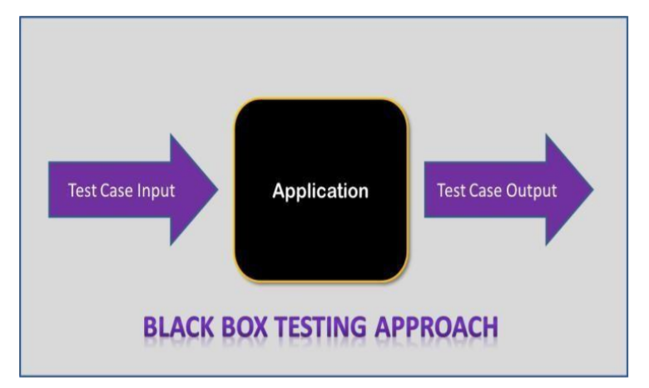

**5.3 UNIT TESTING**

Throughout pc programming and coding, we have this unit testing assisting which of the product tests approaches with the methods for which specific units of the supply code, or a fixed of 1 and now and then additional PC programming component together with related control records, managing procedures, and working methodologies, are experienced and analyzed to see whether they are strong for use. Instinctively, we likewise can locate a unit to be the littlest checkable component of an apparatuses.

The objective of unit checking out is in order to separate every detail of this system and to illustrate that the person factors are accurate

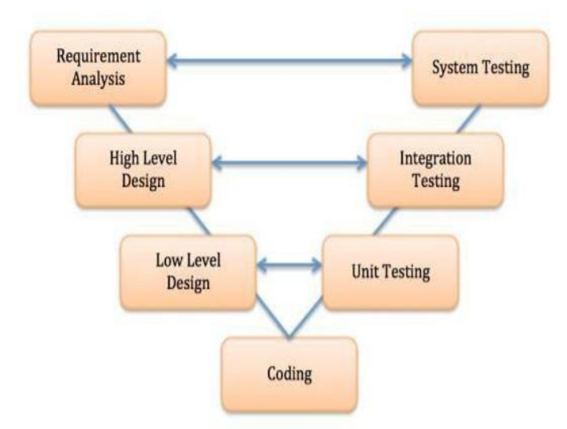

*CHAPTER 6: PROJECT PLANNING*

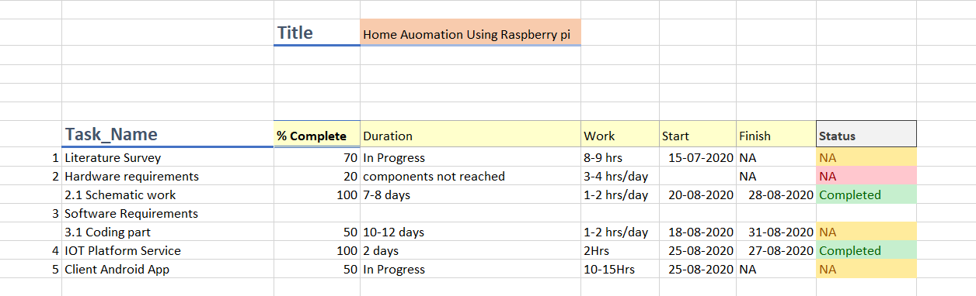

**Work Flow**

*CHAPTER 7: REFERENCES*

1. Hill, Jim (12 September 2015). ["The smart home: a glossary guide for the perplexed"](http://www.t3.com/features/the-smart-home-guide). T3. Retrieved 27 March 2017.
2. ["Best Home Automation System - Consumer Reports"](https://www.consumerreports.org/cro/magazine/2014/06/run-your-home-from-your-phone/index.htm). www.consumerreports.org. Retrieved 2016-02-14.
3. ["5 Open Source Home Automation Projects We Love"](https://www.fastcompany.com/3038442/elasticity/5-open-source-home-automation-projects-we-love). Fast Company. 2014-12-01. Retrieved 2016-11-22.
4. ["Wireless Sensor Networks: Concepts, Applications, Experimentation and Analysis"](https://books.google.com/books?id=oYmwCwAAQBAJ&pg=PA108&lpg=PA108&source=bl&sa=X#v=onepage&f=false). 2016. p. 108. [ISBN](https://en.wikipedia.org/wiki/International_Standard_Book_Number) [9811004129](https://en.wikipedia.org/wiki/Special:BookSources/9811004129). The use of standardized, with [open standards](https://en.wikipedia.org/wiki/Open_standard) over [proprietary protocols](https://en.wikipedia.org/wiki/Proprietary_protocol) provides the industry with the freedom to choose between suppliers with guaranteed interoperability. Standardized solutions usually have a much longer lifespan than proprietary solutions.
5. ["Research and Markets: Global Home Automation and Control Market 2014-2020 - Lighting Control, Security & Access Control, HVAC Control Analysis of the $5.77 Billion Industry"](https://web.archive.org/web/20160505124414/https:/www.reuters.com/article/research-and-markets-idUSnBw195490a%2B100%2BBSW20150119). Reuters. 2015-01-19. Archived from [the original](https://www.reuters.com/article/research-and-markets-idUSnBw195490a+100+BSW20150119) on 2016-05-05.
6. Home Automation & Wiring (1 ed.). New York: McGraw-Hill/TAB Electronics. 1999-03-31. [ISBN](https://en.wikipedia.org/wiki/International_Standard_Book_Number) [9780070246744](https://en.wikipedia.org/wiki/Special:BookSources/9780070246744).
7. Rye, Dave (October 1999). ["My Life at X10"](https://web.archive.org/web/20140930080338/http:/hometoys.com/emagazine.php?url=%2Fhtinews%2Foct99%2Farticles%2Frye%2Frye.htm). AV and Automation Industry eMagazine. AV and Automation Industry eMagazine. Archived from [the original](http://hometoys.com/emagazine.php?url=/htinews/oct99/articles/rye/rye.htm) on September 30, 2014. Retrieved October 8, 2014.
8. ["1.5 Million Home Automation Systems Installed in the US This Year"](https://www.abiresearch.com/press/15-million-home-automation-systems-installed-in-th/). www.abiresearch.com. Retrieved 2016-11-22.
9. Li, Rita Yi Man; Li, Herru Ching Yu; Mak, Cho Kei; Tang, Tony Beiqi. ["Sustainable Smart Home and Home Automation: Big Data Analytics Approach"](http://www.sersc.org/journals/IJSH/vol10_no8_2016/18.pdf) (PDF). International Journal of Smart Home. **10** (8): 177–198. [doi](https://en.wikipedia.org/wiki/Digital_object_identifier):[10.14257/ijsh.2016.10.8.18](https://doi.org/10.14257%2Fijsh.2016.10.8.18).
10. Preville, Cherie (26 Aug 2013). ["Control Your Castle: The Latest in HVAC Home Automation"](http://www.achrnews.com/articles/124160-control-your-castle-the-latest-in-hvac-home-automation). ACHRNews. ACHRNews. Retrieved 15 Jun 2015

*CHAPTER 8: CONCLUSION*

we see raspberry provides security and various ways to control the devices in the house. Because of mobile phones the living is comfortable and at the same time it can be easily accessible through portable devices. It gives users all the rights to decide which makes it reliable as it always asks before taking any decision, it helps when there are any necessary decision, it helps when there are any necessary decisions to be taken and they can be taken fast in case of an emergency.